**Design specifications：**

**Objective for counting and detective system:**

Objective requirement:

Detect the dropping parts in a seal space, no double counting and no missing.

Down to 1 part and up to 6 parts

Each time only detect the parts with same shape.

**Objective for motor control and power supply system:**

**Electrical/Electronic Subsystem:**

For detective and counting system what we considered and followed is shown in the flow chart

Parts detected

Microcontroller

Counting

parts

Detector

Counting completed feedback

The primary thing we did was figuring out the detective method. After thoughtful consideration, we got the result that laser is stable and reliable, but more expensive. Pressure sensor is hard too. Motion sensor is not sensitive enough to detect small parts. IR sensor is perfect working on short distance detection, sensitive and stable. Moreover, it is cheaper enough. Therefore, it became to our final option.

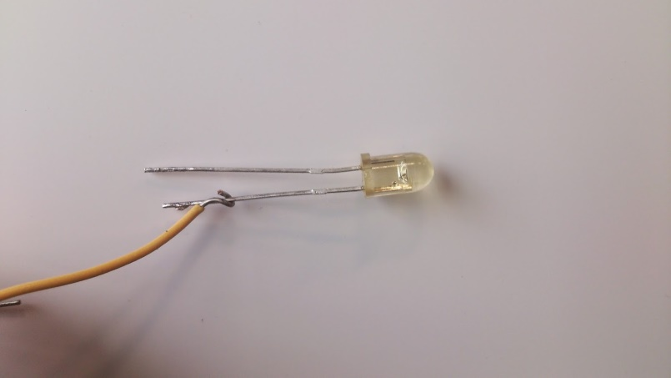

Figure 1 IR led op290

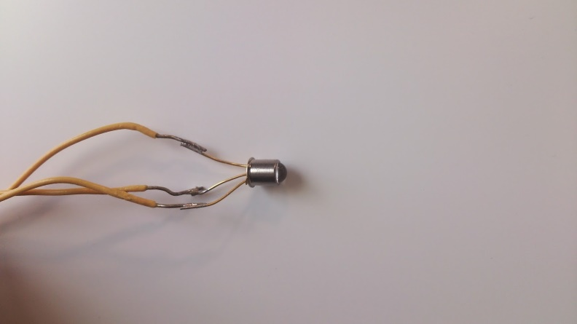

Figure 2 phototransistor OP830SL

Shown in the figure 1, 2 are our IR led and phototransistor. It illustrates infrared detection system which is used through our design. They essentially create a “beam” of IR light between two locations and provide us with a digital “Low” when there is nothing to block it, because when transistor bias, collector pole will pull down to the ground. Inversely, when parts block the “beam” of IR light, BE junction stop work. Thus, collector pole will pull up and the output gets a digital “high”. This efficient system proved to be useful in our design where we needed to know that a part had passed by, such as in counting parts and starting/stopping the machine. During IED and phototransistor selection, angle displacement and

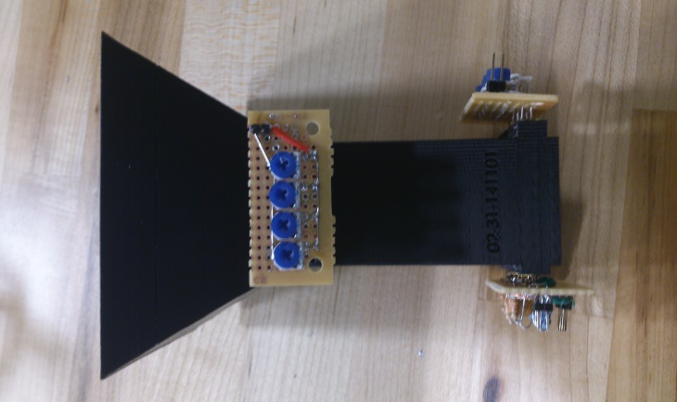

Figure 3 funnel and detection system

The concept sketch of entire system is shown in figure 3. 8 sensors are separated into two layers, 4 sensors parallel with each other to form a cross-section. Two layers have 90 degree difference on angle that if considered from 3 dimensions perspective we can get a grid structure. This structure provided our counting system a most safety detective environment. The sensors are fixed in the funnel which can isolate the sensors from external environment. In this case, we minimized the external disturbing.

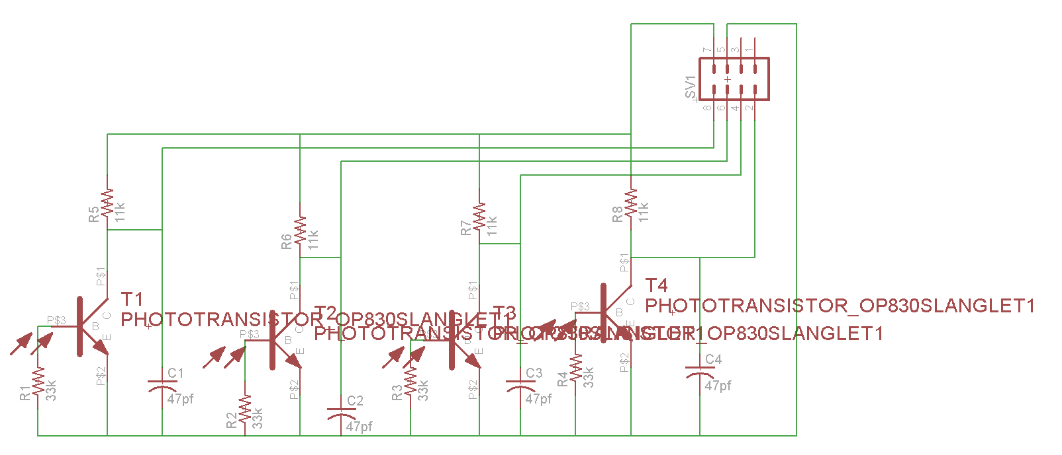

Figure 4 Circuit sketch of receive side for PCB

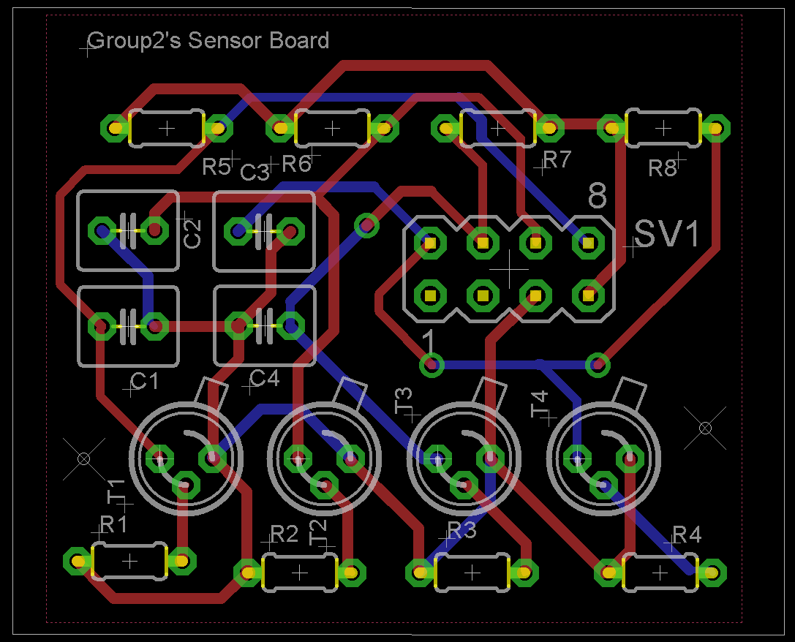

Figure 5 PCB for Receiver side

Shown in figure 4 and 5 are our PCB board design for receiver circuit. The size of board is 42mm*36mm. The interval between each transistor follows the design specification of funnel. Although to print PCB board will be costly, using the PCB can avoid the wires exposure, which decreases the probability of error and block the interference from external environment. Besides, this design optimized the layout of our product, and in order to systematize our product to satisfy the concept of simplification and efficiency, PCB is the best choice for us. However, due to the PCB board need nearly a week's time, but we couldn’t wait for that long. So, finally we changed our mind to solder this board by using common circuit board.

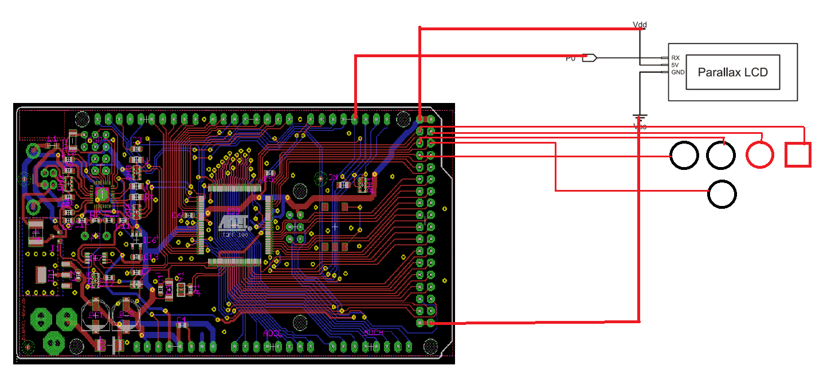

Figure 6. Wires connection of interface

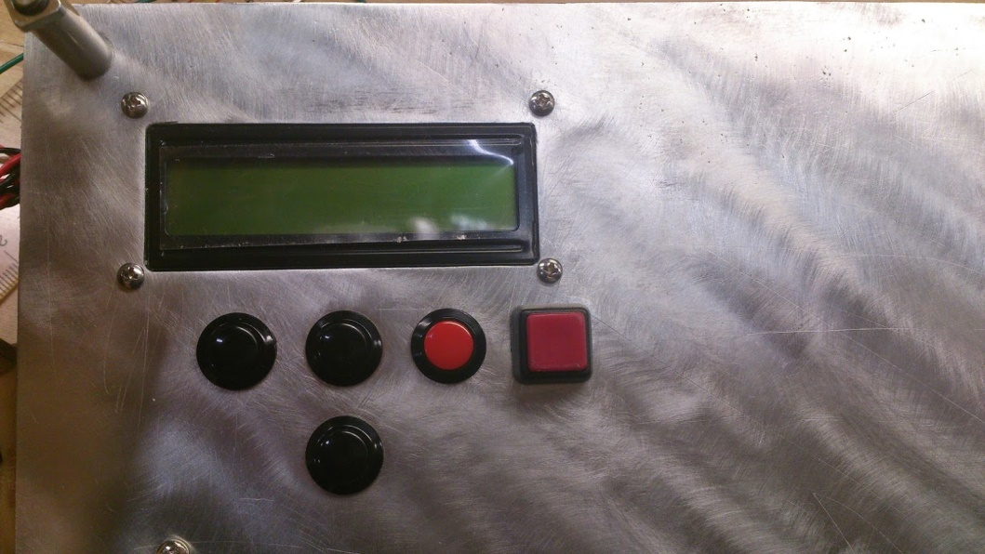

Figure 7 interface out looking

Shown in the figure 8 is wire connection of our interface design. The LCD which we chose is Parallax 27977 with serial interface. Serial interface will reduce the pins usage of Arduino board and also simplifies the coding part. The design of interface follows the idea of concise and high controllability. Five buttons corresponding to the functions: Start. Select, up, down and back which meet the requirements of our expectation to control our design working in order.

Motor setting and connecting

(

)

Wiring and layout

(

)

**Computer/Software Subsystem:**

**Software coding flow chart (interface-LCD display):**

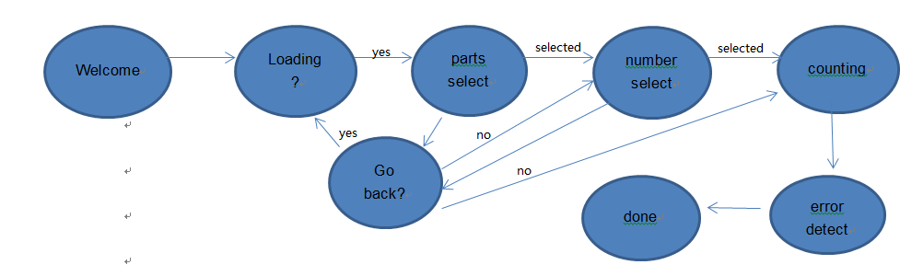

Figure 8 Flowchart of software controlling

Shown above in figure 7 is the flowchart of software working for LCD display part. Following each step we need, we have six steps and 2 judgments during our system’s operation. These logic forms a visual operation platform for user. Consider optimizing users’ experiences, we set back button for use to revise their choice and added error detection to avoid any unexpected error during system counting. Coding used typedef enum and typedef structure to generate a state machine in case switch which could realize to switch the states of LCD display in different mode, and achieve the inverse operation of the program.

**Software coding flow chart (Motor control system):**

**(**

**)**

**Electrical/Electronic Technical Discussion:**

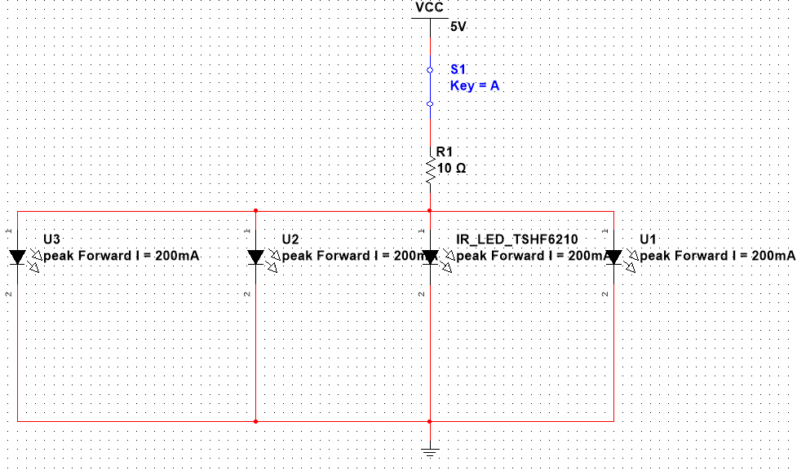

Figure 9 Circuit sketch for emitter side

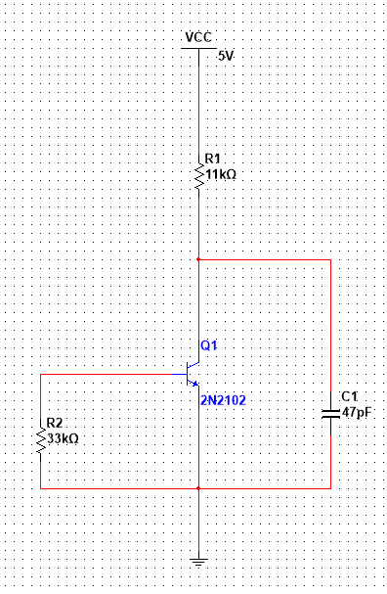

Figure 10 Circuit sketch for receiver side

The circuits shown in figure 9 and 10 are simulation circuit. In receiver circuit, the resistor in base pole side is a pull-down resistor which can clamp the uncertain signal in low and improve the ability to resist electromagnetic interference of the bus. The capacitor in the collector side which connected to ground is used to isolate the noise from ground. In order to avoid the influence of internal resistor of transistor, we picked up 11kΩ as the pull up resistor in the collector side. All the circuit designs of sensor are basin on the knowledge from circuit design courses except refer to the datasheet of the components. In this part, the

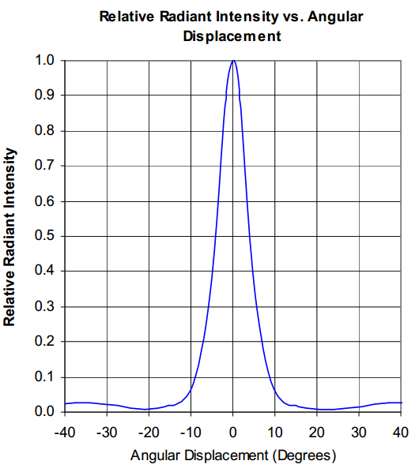

Figure 11 Angle displacement: 10 degrees.

Base on a simple equation the side of plant of illumination equal 26mm * tan10° = 4.584mm. Theoretically on receiver side, IR light will overlap and increase the luminance. As we know, phototransistor is working on switch mode that the only one controllable factor is bias voltage. So, finally we used thyrecotor to control the power of IR led which can change the radiation intensity on the received. To set the voltage across BE junction just higher than the bias voltage by adjusted the value of thyrecotor in lighting conditions. Thus, four sensors will be considered into a single system to analyze which means less instability and easy thinking. The resistance range: refer to datasheet of OP290, the bias voltage of IR led is 0.8v (0.01A) and the max voltage is 3.5v (0.2A).

MAX R:  R=420Ω

MIN R: R=7.5Ω

**Testing of sensor system (sensitive):**

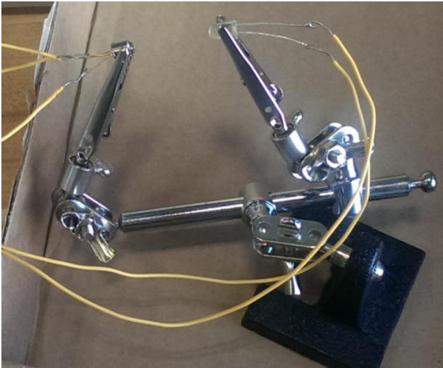

Figure 12. Sensor sensitive testing

In order to test the performance of our detective components, we designed the testing circuit to test repeatedly under different conditions. The testing plat is shown in figure 8.By observing the amount of variation of voltage, we could figure out whether sensor works sensitively. The results are shown in chart below:

|  |  |  |
| --- | --- | --- |
| Distance | Sensitive | Value of resistor |
| 20mm | High/High/High | 100Ω/45Ω/25Ω |
| 26mm | High/High/High | 100Ω/45Ω/25Ω |
| 30mm | Mid/High/High | 100Ω/45Ω/25Ω |
| 40mm | Mid/Mid/High | 100Ω/45Ω/25Ω |
| 50mm | Low/Mid/High | 100Ω/35Ω/25Ω |
| 60mm | Low/Mid/Mid | 100Ω/45Ω/15Ω(a little heated) |
| 70mm | NA/Low/Mid | 100Ω/45Ω/15Ω(a little heated) |
| 80mm | NA/Low/Mid | 100Ω/45Ω/15Ω(a little heated) |

Through the data in the chart, our detection system worked perfectly in the distance of 26mm. Up to 80mm interval between emitter and detector, it still works. So, for the stability and sensitive of our detection system, it could be used in any short range detection.

**Testing of sensor system ( Reflection time):** (most of this part is from Byran’s repeort)

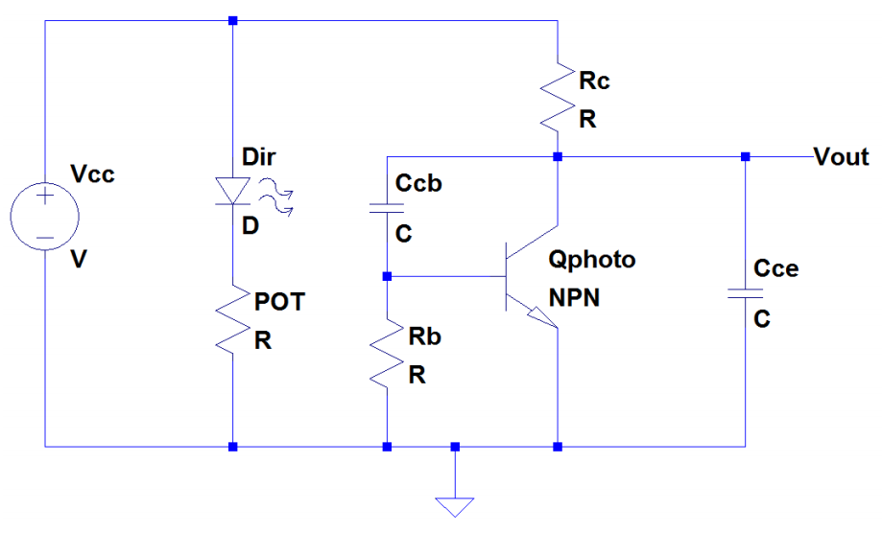

Figure 13 A schematic of the IR LED and phototransistor circuit.

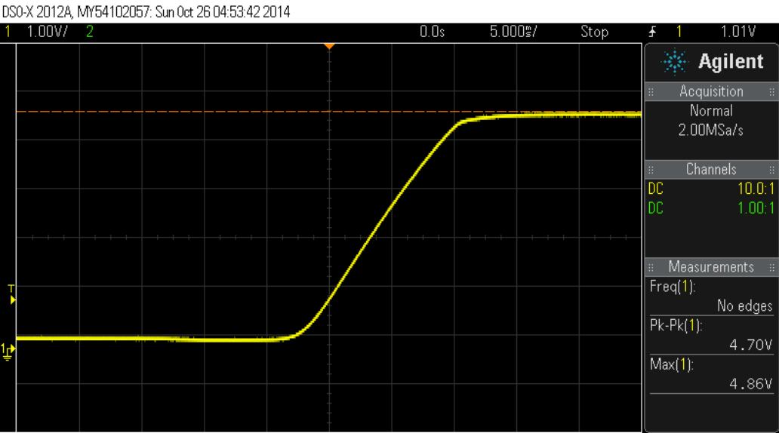

Figure 14. The waveform of the initial test of the phototransistor's rise time.

In order to evaluate the rise time of the circuit, we needed to identify the minimum rise time necessary for the transistor circuit. We identified that the rise time needed to sufficiently small so that the output voltage would reach greater than +3V before the object has completely passed through the path of the beam. To compute a nominal value of this, we examined the kinematics of the situation. We identified that the object would be in freefall and the shortest time interval for detection would occur when the object is at its greatest velocity. With these considerations, we computed the objects velocity at the bottom of the funnel. We found the velocity to be approximately 2.2m/s. Next, using the width of the smallest part, we computed the minimum time interval for detection. We computed the minimum time interval for detection to be approximately 4ms. As a result, we defined that the maximum acceptable rise time must be less than 4ms.

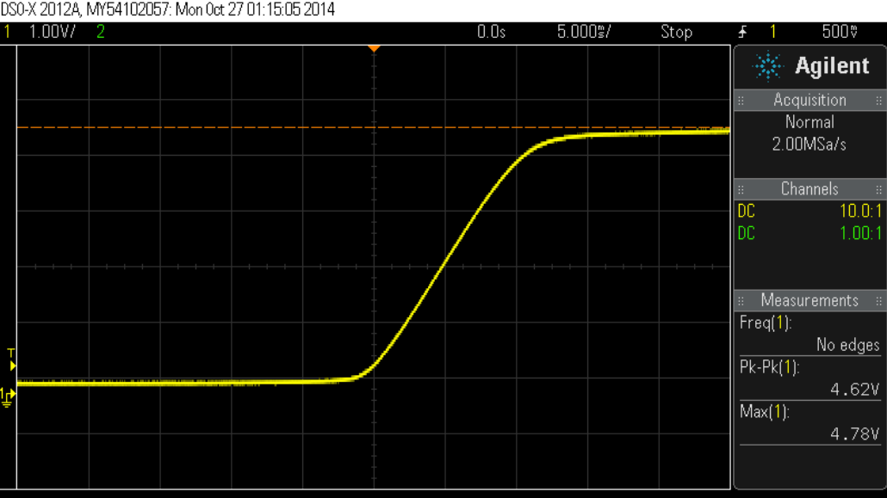

Figure 15 The waveform of the rise time due to changing CCE.

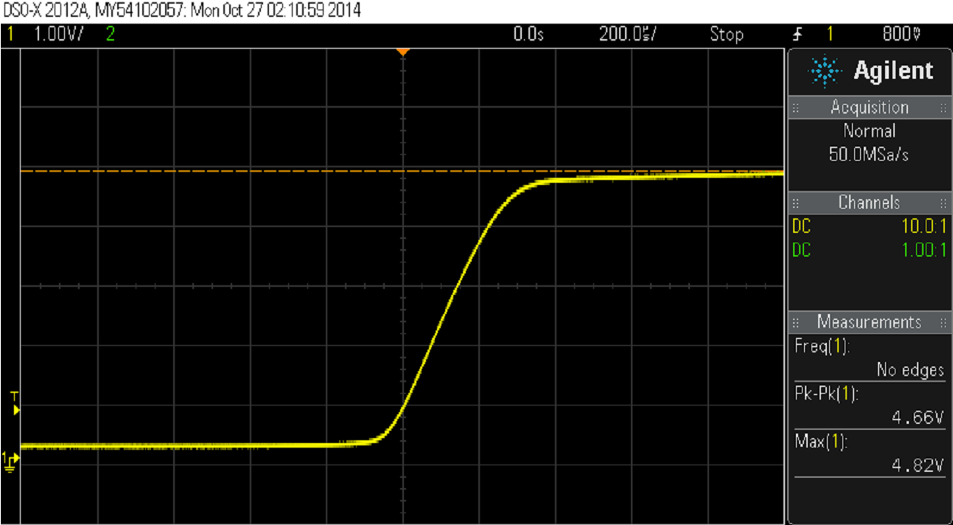

Figure 16 The waveform of the rise time due to removing CCB.

The rise time of the phototransistor was evaluated using the circuit depicted in Figure 13 and the physical configuration depicted in Figure 14. We used a 33kΩ and 11kΩ resistors for RC and RB, respectively, and 1nF and 47nF capacitors for CCE and CCB respectively. By blocking the light we evaluated the response of the phototransistor. Figure 15 displays the rise time of the sensor as observed by the oscilloscope using these values. As can be seen the rise time of the circuit is approximately 10ms, which is unacceptable by the criterion previously established. Figure 15. The waveform of the initial test of the phototransistor's rise time.Since the configuration did not meet standards, we needed to adjust the time constant of the circuit.

Initially, we decreased the value of CCE which decreases the time constant. We changed the value of the capacitor to 1nF. The voltage output after the test as observed by the oscilloscope is depicted below in Figure 16. As can be seen in the figure, changing this capacitor did not affect the rise time significantly.

The rise time of the phototransistor was evaluated using the circuit depicted in Figure 14 and the physical configuration depicted in Figure 15. We used a 33kΩ and 11kΩ resistors for RC and RB, respectively, and 1nF and 47nF capacitors for CCE and CCB respectively. By blocking the light we evaluated the response of the phototransistor. Figure 16 displays the rise time of the sensor as observed by the oscilloscope using these values. As can be seen the rise time of the circuit is approximately 10ms, which is unacceptable by the criterion previously established. Figure 16. The waveform of the initial test of the phototransistor's rise time.Since the configuration did not meet standards; we needed to adjust the time constant of the circuit.

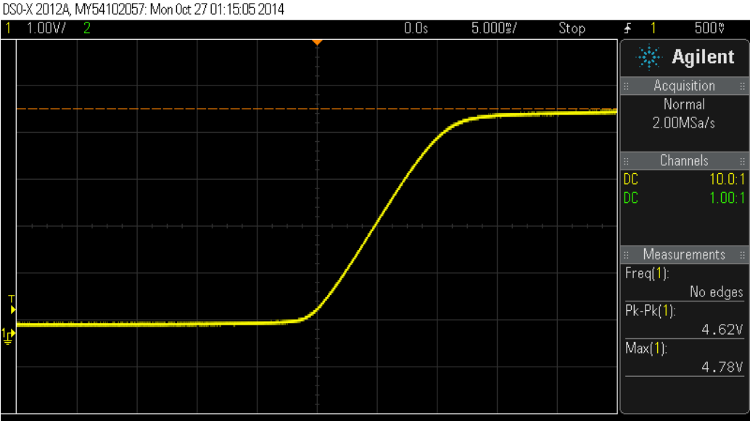

Figure 17. The waveform of the rise time due to changing CCE.

Since CCE did not affect the rise time significantly, we investigated the affect of CCB on the time constant. We quickly realized that this capacitor, which is in parallel with the Miller Capacitance of the transistor, has a much greater effect of the time constant of the circuit due to the current gain of the transistor, β.As a result, we changed CCE to 47pF and removed CCB from the circuit. As a result, the circuit is configured as appears in Figure 17. We tested the circuit under this configuration and observed the rise time to be significantly improved to 350μs, as can be seen in Figure 6. Since the rise time is significantly lower than the criteria established earlier, the circuit meets our specifications.

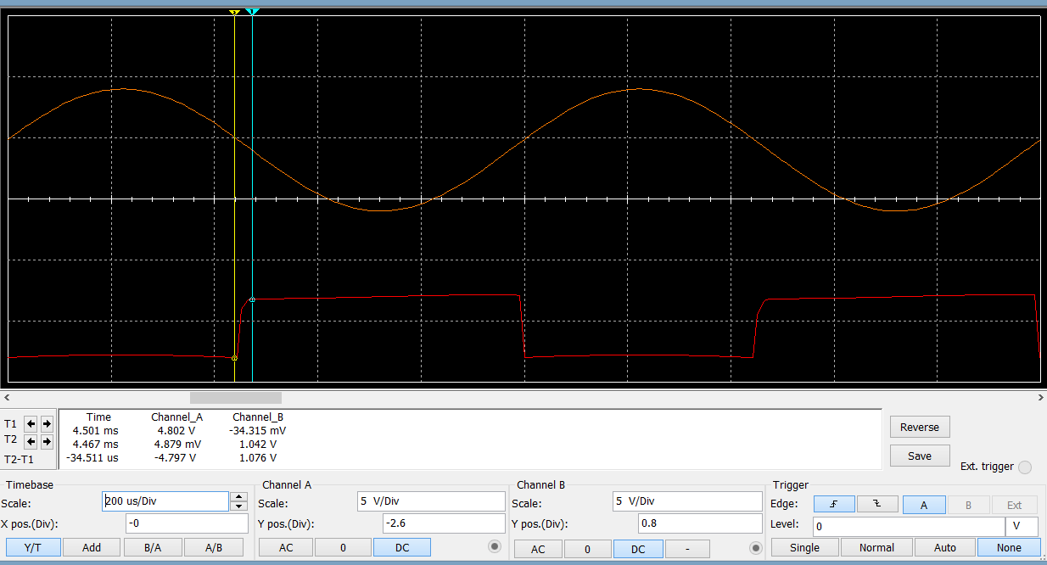

Figure 17 simulation for sensor circuit

Comparing with the simulation result in figure 17 which shows the reflection time of voltage rising is 34.511us, the result (16us) what we got from real testing is lower than our simulation result for more than two times. It illustrated that our actual result is better than our simulation result.

**Sensor’s safety evaluation:**

Our sensors were set in a closed space. Few radiation of IR light could permeate from funnel inside. Furthermore, through our researching, Infrared (IR) radiation consists of wavelengths from 760 nm to 1 mm, and it is subdivided into three regions of increasing wavelength, IR-A (760–1400 nm), IR-B (1400–3000 nm), and IR-C (3000 nm–1 mm). The wavelength of our IR Led is just 890 nm which belong to IR-A. It has been reported that IR-A can penetrate epidermal and dermal layers and reach subcutaneous tissues without increasing the skin temperature significantly. Therefore, our detective system will never damage user in the case IR radiation.

**Interface performance and discussion:**

**Motor performance and discussion:**

**Software coding discussion:**

**Conclusion/Recommendations**

Cited:

http://www.nature.com/jidsp/journal/v14/n1/full/jidsymp20097a.html